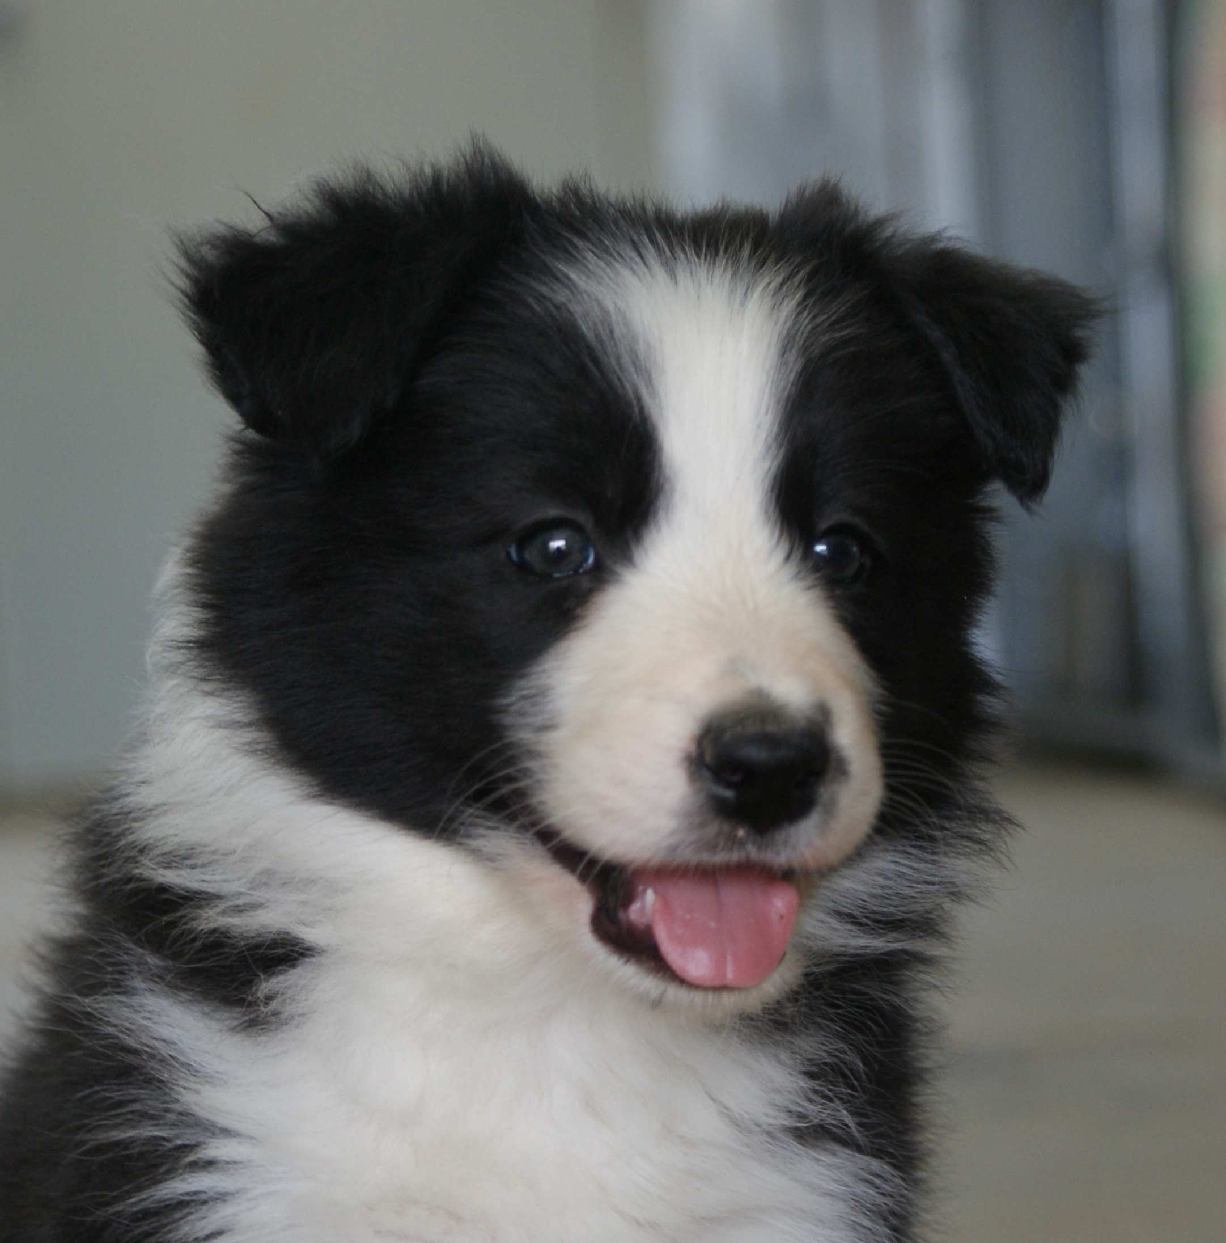

SALES CONTRACT

Double M Stockdogs (Molly Wisecarver, owner, breeder) hereafter referred to as Seller.
On January 24, 2021 the amount of $ 1,200.00 has been received from:

XXXXXXXXXXXXXXXXX

Hereafter referred to as Buyer. For the purchase of the Border Collie described below:

8 week old Blue Merle colored Male Border Collies puppy. Whelp November 25, 2020. Sired by xxxxxxxxxx X xxxxxxxxxxx. Both parents were clear of all tested genetic diseases and have certified and registered OFA and/or Penn hips scores at the time of this mating.

1. The Seller certifies that the said Border Collie pup is a purebred Border Collie and that the pedigree attached to this Agreement is true and correct. This Border Collie puppy is in sound body and in good health, free from communicable diseases to the best of knowledge of the Seller, and current in vaccinations and worming. Buyer agrees to have the Border Collie examined by his/her veterinarian within one week from the time of arrival. Buyer must notify seller immediately of any medical problems found.

2. This Border Collie may be returned in the same condition as it was when it left the Seller, within one week from the date of arrival, if the Border Collie is found to have a genetic or serious medical problem upon examination for a full refund of the purchase price $1000.00 with in that week. Buyer may also return the Border Collie within one week for a full refund if Buyer is not completely satisfied with the puppy.

3. The seller guarantees this puppy is free from hip dysplasia and CEA. If at age 2 years old, this Border Collie has a hip score showing dysplasia, the seller will offer a puppy from a future litter at no cost to the buyer.

4. The sale of this Border Collie includes: AKC registration (to be mailed), a three generation pedigree, schedule of vaccinations, worming, grooming tips and feeding instructions.

5. “Double M Stockdog” (Molly’s DBLM) Prefix Requirement: Buyer must use the kennel name prefix “Molly’s DBLM” when exhibiting or registering this Border Collie.

6. This Border Collie puppy will reside at the home of the Buyer, have access to a fenced yard, not be chained or tethered, and will be provided with proper housing, a good quality diet, annual shots and exercise. Buyer must provide Border Collie with necessary veterinary care upon sickness, disease, or injury. Buyer must provide Border Collie with humane care.

7. The buyer agrees to keep the Breeder informed as to their address and the status of the above Border Collie and will return to breeder in case they have to part with this Border Collie at any time during the Border Collie’s lifetime. If Buyer decides to sell the Border Collie, Seller must be notified and has first right of refusal at the purchase price. Buyer agrees to never give up this Border Collie to any Rescue Groups or Humane Society, but will contact the Seller to return the Border Collie.
8. The Buyer agrees that the Breeder is in no way liable or responsible for any damage, accident, or injury resulting from the dog.
9. Spay/Neuter provision. Buyer agrees that Puppy shall not be used for breeding purposes until the following certifications have been received by the Seller:

a. Orthopedic Foundation for Animals (OFA) Certification of hips,
elbows, has been received.

b. The Canine Eye Registration Foundation (CERF) within 12 months of planned breeding.

c. An additional fee of $500.00 paid to seller to release breeding rights.

If this Border Collie has not been exhibited in any venues (conformation, agility, herding, obedience) it will be considered a pet and therefore the Buyer agrees to have the bitch spayed or the dog neutered and will not be used for breeding purposes. Exception to this would be an injury that would prevent the Border Collie from participating in performance and conformation events. If this Border Collie is otherwise healthy this exception will be considered.

The Seller shall not sell the puppy, or its offspring (if any), to any individual or establishment in the business of buying and selling puppies for a profit.

10. Buyer agrees not to Neuter or Spay their puppy until he/she reaches the age of 16 month. If the buyer neuters or Spay their dog before this time Double M Stockdogs will not honor the genetic guarantee against Hip Dysplasia or OCD. If the buyer feels he needs to neuter or spay before this time please call the breeder to discus and an agreement can be meet

This Agreement is made and signed by both parties to insure the well-being and protection of this puppy.

I the undersigned understand and agree to the terms and conditions of this sale January 24, 2021

________________________________ _____________________________
Breeder/Seller: Molly Wisecarver Buyer:

